Directions to Vel J. Phillips Juvenile Justice Center
10201 Watertown Plank Road, Wauwatosa WI 53226
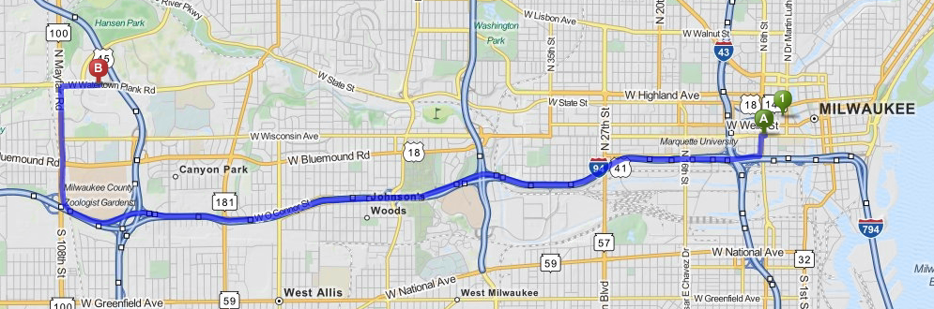

 | 1. | Start out going west on W Wisconsin Avetoward N 6th St. | 0.04 mi
 | 2. | Take the 1st left onto N 6th St.  - Sammy's Taste Of Chicago is on the corner  - If you reach N James Lovell St you've gone a little too far | 0.2 mi
 | 3. | Turn right onto W Clybourn St.  - W Clybourn St is just past W Michigan St  - Herzing University is on the right | 0.09 mi
 | 4. | Merge onto I-794 W toward I-94 W. | 0.8 mi
 | 5. | I-794 W becomes I-94 W. | 5.8 mi
 | 6. | Merge onto WI-100 N/N Mayfair Rd viaEXIT 304B. | 1.2 mi
 | 7. | Turn right onto W Watertown Plank Rd.  - W Watertown Plank Rd is 0.2 miles past W Research Dr | 0.4 mi
 | 8. | 10201 W WATERTOWN PLANK RD is on the right.  - Your destination is 0.1 miles past W Innovation Dr  - If you reach N Swan Blvd you've gone about 0.1 miles too far

