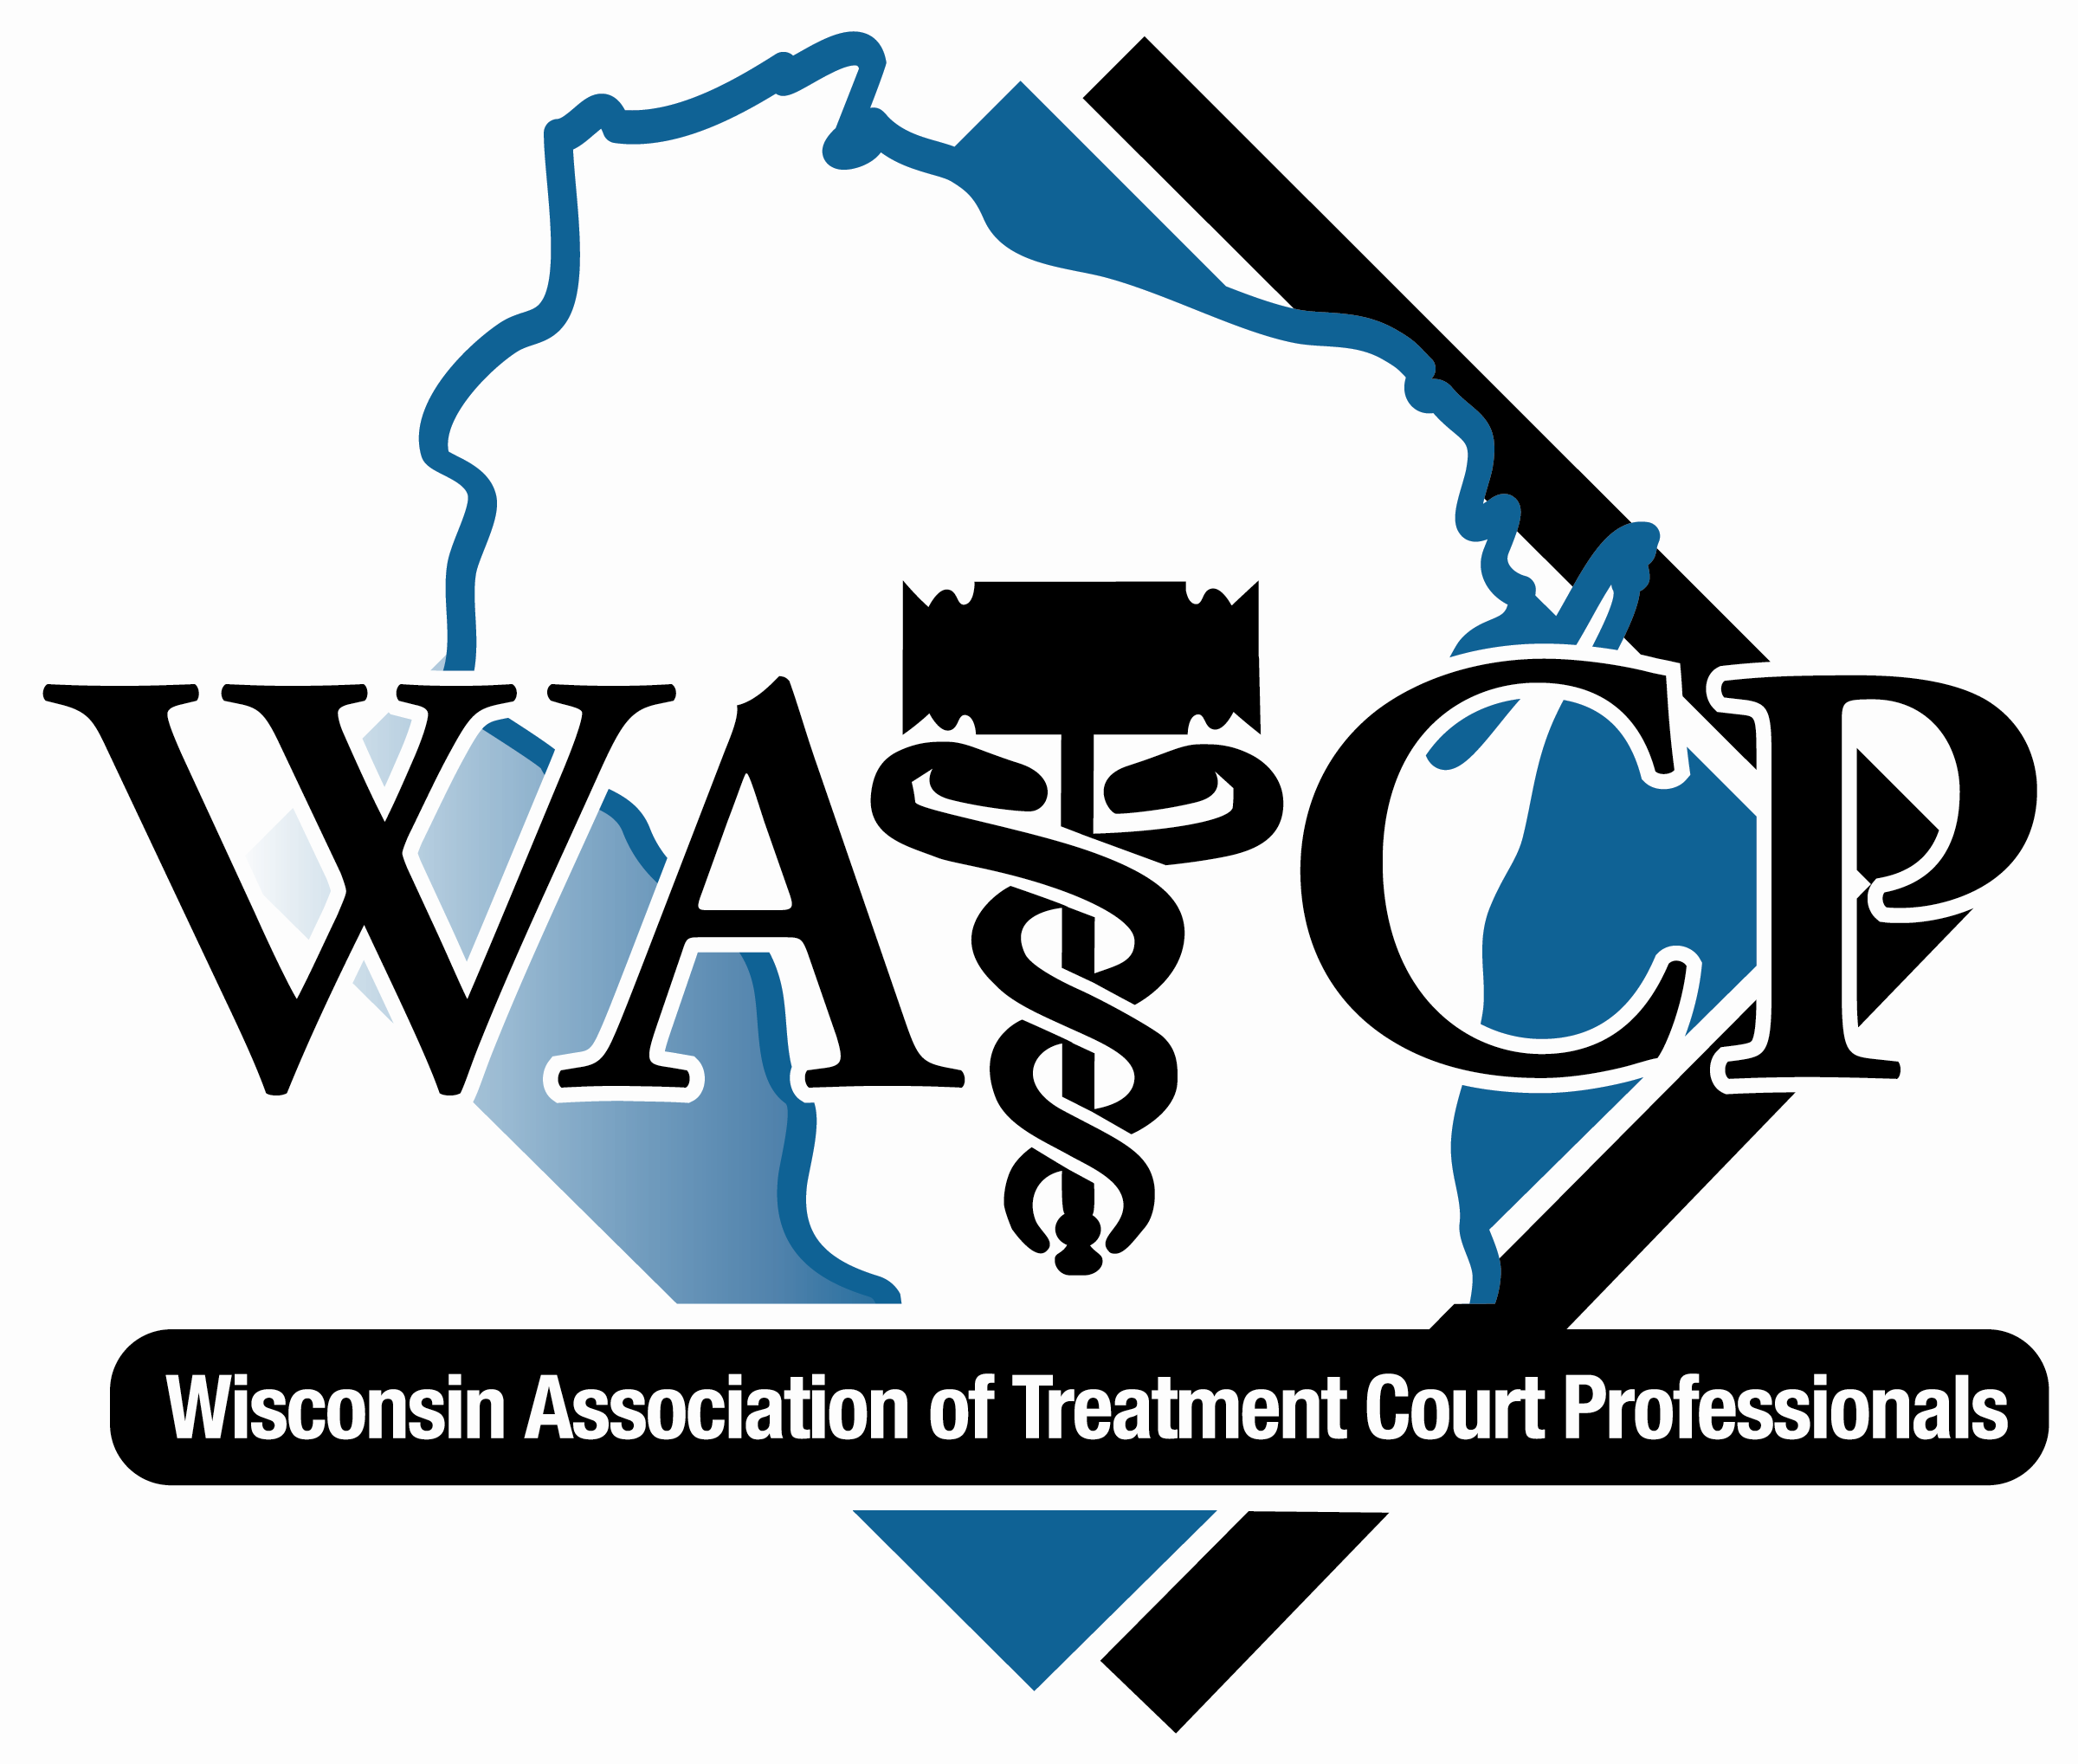

WATCP

11th Annual Conference

Milwaukee, WI

Monday, March 23, 2015

7:00 am – 8:00 am Registration & Breakfast 4th Floor Foyer

8:00 am – 10:00 am Drug Court 101 (Agenda on next page) Crystal Ballroom
Honorable Glade Roper

10:00 am - 10:15 am Break

10:15 am – 12:00 pm Drug Court 101

12:00 pm – 1:00 pm Lunch Crystal Ballroom

1:00 pm – 3:00 pm Drug Court 101

3:00 pm – 3:15 pm Break

3:15 pm – 5:00 pm Drug Court 101

REGISTER EARLY!!!!!!

5:00 pm -7:00 pm CONFERENCE REGISTRATION 4th Floor Foyer

Avoid the morning rush and long lines

Wisconsin Association of Treatment Court Professionals Annual Conference
March 23, 2015

Hon. Glade F. Roper, Tulare County Superior Court (Ret)

I. Who Do You Want In Drug Court?

A. The difference between addiction and use

B. The Nature of addiction

II. Behavior Modification Principles

A. Criminal court ineffective at behavior modification

B. Problems with punishment

1. Definitions

a. Punishment

b. Negative reinforcement

c. Positive reinforcement

2. Punishment can be a reward and vice versa

3. Intensity of punishment

a. Habituation

b. Tolerance

c. Invitation to test limits

d. Abandonment

e. Exhaustion of options

4. Undesirable behavior must be reliably detected

5. Celerity

6. Attitude of delivery

7. Punish behavior, not addiction

III. Use of Positive reinforcements

IV. Responding to Drug Use Episodes

A. Difference between use episode and relapse

B. Responding to positive tests

C. Strict compliance at the outset is unrealistic

D. Effect of having a fixed sanction schedule

V. Working with 12-Step Fellowships

A. Verifying attendance at meetings

B. Recent case law about compulsory attendance at AA and NA meetings

C. Working with fellowships

D. Court involvement in working the 12 steps

VI. Testing Issues

A. New “Designer Drugs”

B. Denial of use and due process

WATCP

11th Annual Conference Milwaukee, WI

Tuesday, March 24, 2015

7:00 am – 8:00 am Registration 4th Floor Foyer
Breakfast Crystal Ballroom
8:00 am - 8:10 am Welcome and Introductions Crystal Ballroom
Carol Carlson, WATCP President

8:10 am – 8:30 am Opening Remarks Crystal Ballroom
Evan Goyke, State Representative
John Chisholm, Milwaukee Co. District Attorney

8:30 am – 10:00 am Current Research Findings Crystal Ballroom
Dr. Douglas Marlowe

10:00 am – 10:15 am Break

10:15 am – 11:30 am Current Research Findings Crystal Ballroom
Dr. Douglas Marlowe

11:30 am – 12 pm Updates on Laws re: Treatment Courts Empire Ballroom
WATCP Board Meeting

12:00 pm – 1:00 pm Lunch and the Aulik Award Crystal Ballroom

1:00 pm – 1:30 pm Brad Schimel- WI Attorney General Crystal Ballroom

1:30 pm – 3:00 pm Sanctions and Incentives Crystal Ballroom
Dr. Douglas Marlowe

1:30 pm – 3:00 pm Complex Interactions of PTSD, Juneau Room
Pain and Substance Abuse
Dr. Brian Meyer

3:00 pm – 3:15 pm Break

3:15 pm – 4:45 pm Improving Treatment Outcomes: Juneau Room
Resources for Employment Training &
Placement Marjorie Blaschko, Eau Claire DVR

3:15 pm – 4:45 pm PTSD and Substance Abuse in Veterans Crystal Ballroom
Dr. Brian Meyer

3:15 pm – 4:45 pm Family Court 101 Oak Room
Honorable Mary Triggiano/Rebecca Foley-Coordinator

WATCP

11th Annual Conference

Milwaukee, WI

Wednesday, March 25, 2015

7:30 am – 8:00 am Registration 4th Floor Foyer
Breakfast Crystal Ballroom

8:00 am - 8:15 am Welcome and Introductions Crystal Ballroom
Carol Carlson WATCP President

8:15 am – 8:30 am Opening Remarks Crystal Ballroom
Chris Abele, Milwaukee County Executive

8:30 am – 9:45 am Trauma and Treatment Courts Crystal Ballroom
Tim Grove, MSSW; Honorable Mary Triggiano

9:45 am - 10:00 am Break

10:00 am – 11:00 am Compassion Fatigue in Treatment Crystal Ballroom
Court Professionals
Tim Grove, MSSW; Honorable Mary Triggiano

11:00 am – 12:00 pm Graduate Panel Crystal Ballroom

12:00 pm – 1:00 pm Lunch Crystal Ballroom

1:30 pm – 4:00 pm Visit to Milwaukee County Treatment Courts
Milwaukee Co. Adult Drug Court or Family Court

OR

1:00 pm – 3:30 pm Veterans Court Crystal Ballroom
Honorable Robert Russell, Buffalo Vets Court
Jack O’Connor, Mentor Coordinator

1:00 pm – 3:30 pm Best Practices in Assessment, Supervision Juneau Room
and Treatment of Impaired Drivers
Mark Stodola, Probation Fellow
American Probation and Parole Association

