South Dakota
Problem-Solving Courts
Chemical Dependency and Mental Health Service Provider Orientation
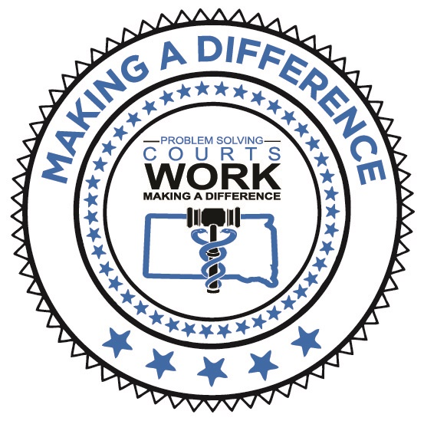

Welcome to the Problem-Solving Court (P-SC) Chemical Dependency and Mental Health Treatment Services Provider Orientation. Research has concluded that P-SCs significantly reduce drug abuse and crime, and do so at far less expense than any other criminal justice strategy. The P-SC model is more effective than treatment alone or court alone for offenders whose legal problems stem from a substance use diagnosis. Using the leverage of the justice system, the P-SC can ensure offenders show up and participate in treatment.
The clinician(s) who provide services and make treatment recommendations (assessment, individual or group) for the P-SC client must understand the model and how it contributes to the treatment plan. The P-SC model includes weekly court, intensive community supervision, frequent and random drug testing, and other wrap-around services. These factors must be taken into consideration as part of the individualized treatment plan.
It is in your best interest to complete the attached orientation. Please submit your name, email address, name of Treatment Agency and the Court in your area to Cody Westergren (cody.westergren@ujs.state.sd.us). Once she receives this information, she will email you needed paperwork.
Thank you.

(*Drug, DUI, Veterans, and Mental Health Courts can be referred to as Problem-Solving Courts or P-SC)

- Review the Policy Manual (provided by Cody)

- Review the Adult Drug Court Best Practices (provided by Cody)
  - I - Target Population
  - V – Substance Abuse Treatment
  - VI – Complimentary Treatment and Social Services

- Create an account at www.treatmentcourts.org and complete the following lesson:
Role of the… (in your specific role with the team)
    - Treatment Provider (38 min)
- Attend one Team meeting/staffing
- Attend one Court session

Additional Information:

- Review the following publications at www.ndci.org – Resources –Publications – Fact Sheets:
- The Responsible Use of MAT for Treatment Court Participants (16 pages)
- Six Steps to Improve Outcomes for Adults with Co-Occurring Disorders (28 pages)

