TIME OUR GREATEST COMMODITY OR OUR THORN OF CONTENTION?
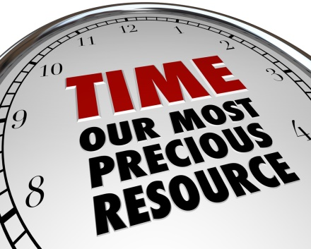
Do you feel like you have no time? No time to do something you want or like? Or do you feel like if you just had more time things would be different? Or are you happy and satisfied with the time you have and how you utilize it?
Let’s take a look at time:
There are 168 hours in the week, how are you using them?
- Sleep = ______________________ Per week?
- Work = ______________________
- Commute = __________________
- Chores = _____________________ (inc. shopping, cleaning, etc)
- Daily rituals = _________________ (eating, showering, restroom)
- Self-care = ____________________ (reading, working out, meditation, yoga, etc)
- Anything else = ________________
TOTAL UP ALL THE HOURS YOU USE: ________________
Subtract this above total from 168 hours- what do you have left over?
________________________________
LOVE YOU HOURS
When you catch yourself saying,
“If I had time I would _______________.”
Do something like…..

- Ok- make that list, what is 1 thing you could use 1 of the “leftover” hours for to take care of yourself better? ________________________________________________________________________________________________________________________________________________
(I will look commit to_____________ by this date __________)

- What is one thing you can do to feed your spirit, or creative, or curious side?
____________________________________________________________________________________________________________________________________________________________
(I will look commit to_____________ by this date __________)

- What is one thing you might consider trying, or exploring, or something you have secretly thought about that you might’ve let fear or self-talk, talk you out of or brush off?
____________________________________________________________________________________________________________________________________________________________
(I will look commit to_____________ by this date __________)

- What is one thing you might consider adding to your future lists or bucket list?
____________________________________________________________________________________________________________________________________________________________
(I will look commit to_____________ by this date __________)

