South Dakota
Problem-Solving Courts
Team Member
Orientation
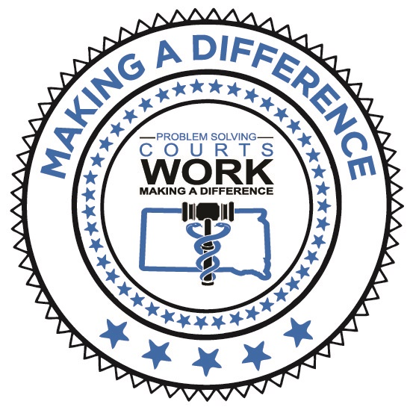

Welcome to the Problem-Solving Court Team Member Orientation. It takes innovation, teamwork, and strong judicial leadership to achieve success when addressing drug-using offenders in a community. Research has concluded that Problem Solving Courts significantly reduce drug abuse and crime, and do so at far less expense than any other criminal justice strategy. It is crucial for every Team member to complete this orientation to be an effective Team member.
The first step in becoming a contributing member of the Team is to learn your role. The information contained in this orientation will allow you to translate Adult Drug Court Best Practices into learning this role. The research is clear: programs that achieve the most promising results are aligned with Best Practices. Best Practices ARE the Problem-Solving Court model.
As a trained Team member, you will apply this knowledge to day-to-day operations of the court. This orientation includes fact sheets and on-line learning lessons to familiarize you with the Problem-Solving Court Model.
As you complete each lesson, track your progress by checking-off boxes and printing certificates when applicable. Please complete the lessons outlined within indicated timeframes. Once the required lessons have been completed, you will be ready to participate at the table as a contributing member of the Drug Court Team.
Thank you for volunteering be part of the Team. You can contact Cody Westergren at cody.westergren@ujs.state.sd.us if you have any questions or difficulty with the online orientation.
(*Drug, DUI, Veterans, and Mental Health Courts can be referred to as Problem-Solving Courts or PSC)

In the first 30 Days: (due by ___________________________)
- Review the Policy Manual (provided by Coordinator)
- Review the Participant Handbook (provided by Coordinator)
  - Understand the Phase Structure & Phase Requirements
- Review the Adult Drug Court Best Practices Volume I & Volume II (copy provided by Cody Westergren or you can access online)
  - www.ndci.org – Resources – Publications – Adult Drug Court Best Practice Standards
- Create an account at www.treatmentcourts.org and complete the following lesson:
Role of the… (in your specific role with the team)
    - Treatment Provider (38 min)
    - Coordinator (35 min)
    - Judge (1-hour 25 min)
    - Probation Officer (1 hour)
    - Defense Attorney (19 min)
    - Prosecutor (73 min)
    - Law Enforcement representatives review “Law Enforcement Guide to Treatment Court” at www.ndci.org – Resources – Training – E-Learning

Once the Lesson has been completed you will receive a certificate. Please print the certificate and email a copy to cody.westergren@ujs.state.sd.us.

At www.treatmentcourts.org, complete:
- Understanding Drug Use and Addiction (65 minutes)
- Confidentiality (27 minutes)
- Incentives and Sanctions (40 minutes)

Within the next 60 Days of employment:
(due by _____________________)
- Complete the remaining www.treatmentcourts.org Adult Drug Court lessons
  - Successful Drug Testing (68 min)
  - Cultural Competency (43 min)
  - Trauma Informed Care (32 min)
  - Implementing Evidence-Based Practice (69 min)

Within 90 Days: (due by _____________________)
- Review the following publications at www.ndci.org – Resources –Publications – Fact Sheets:
- (All Team members)
- Making the Most of Incentives and Sanctions (12 pages)
- Targeting the Right Participants for Adult Drug Court (12 pages)
Treatment Providers:
- The Responsible Use of MAT for Treatment Court Participants (16 pages)
- Understanding and Detecting Prescription Drug Misuse and Misuse Disorders (18 pages)
- Six Steps to Improve Outcomes for Adults with Co-Occurring Disorders (28 pages)
Court Services Officers:
  - Probation Practices in Treatment Court (16 pages)
  - Selecting and Using Risk Need Assessments (23 pages)
  - Understanding and Detecting Prescription Drug Misuse and Misuse Disorders (18 pages)
  - Designer Drugs: What Drug Court Practitioners Need to Know (14 pages)
  - The Marijuana Detection Window (16 pages)

