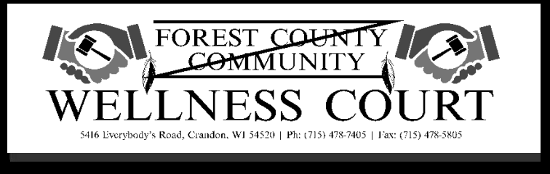
Working with a Native American Population
Cultural Sensitivity/Diversity

What Will The Training Do:
- Provide a “Cultural” awareness
- Offer a different perspective of looking at a group of people
- Explore current biases
- Review current values and biases
- Have you told a racial joke
- Are you prejudice?
- What values can you expect to hear from your Native American clients/participants?
- Examine your organizational expectations in regard to this, and other cultural groups.

What Training Can’t Do:
- Change personal values and attitudes
- Change the way the community perceives your organization, unless the community is involved in the development and implementation of training.

Definitions:
- Race
- A biological trait.
- You are born with it.
- It never changes.
- Ethnicity
- We are born into it.
- Our ethnicity never changes, although it can determine what we do or don’t do.
- Culture
- Something we develop and share with groups of people.
- It is always changing and we are always picking up tools and placing into our cultural kit bag.

- Awareness
- Paradigms
- Stereotypes - Positive and negative

- Questions.
- True or False

- Cultural Values
- Background
- Family
- Belief system

- What does history tell us?

- What does your court /Organization look like?

- Questions and Answers.

