Let’s Care about Your Care!

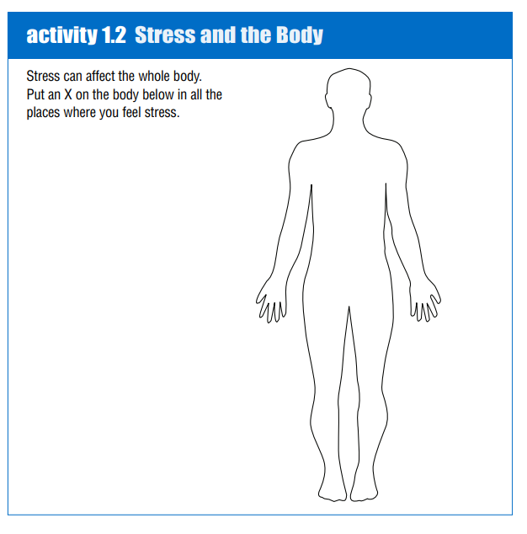

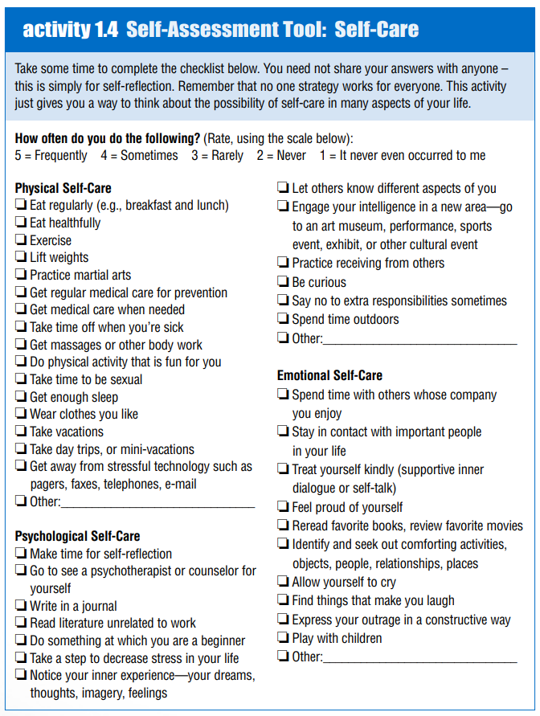
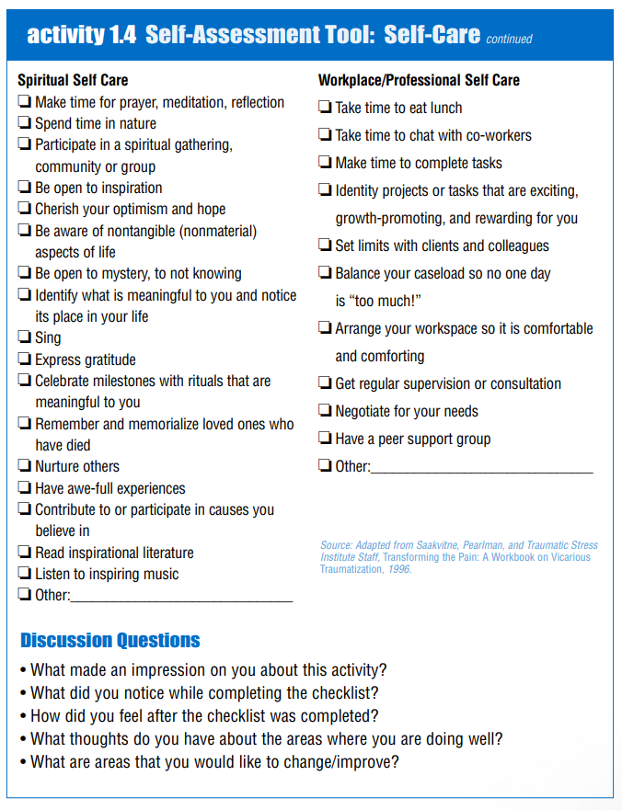
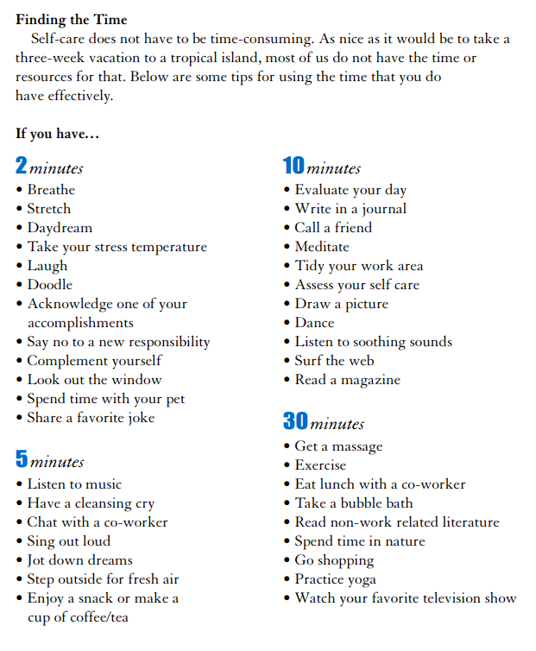

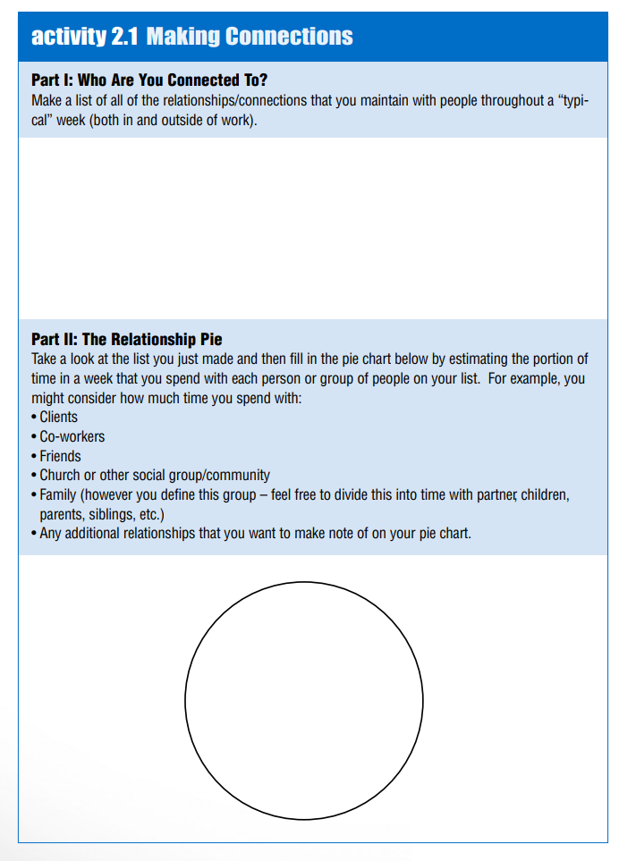
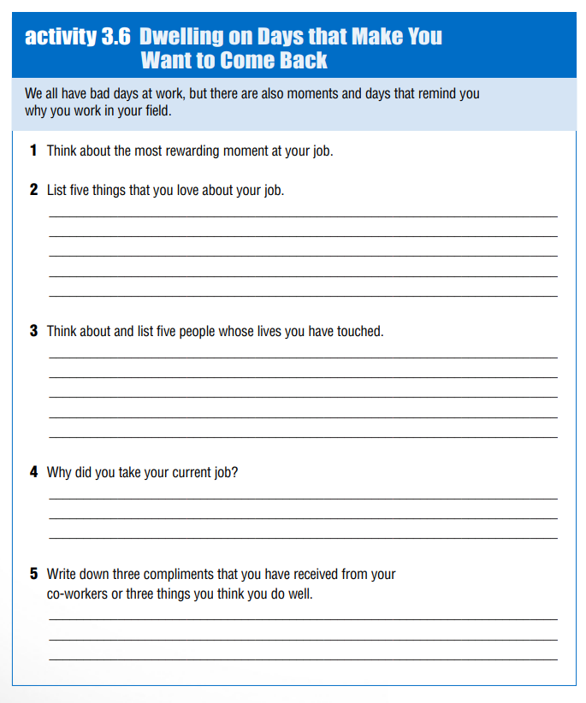

PURPOSE
____________________________________________________________________________________________________________________________________________________________________________________________________________________________________________________________________________________________________________________________________________________________________________________________________________________________________________________________________________________________________________________________________________________________________________________________________________________________________
Mission
____________________________________________________________________________________________________________________________________________________________________________________________________________________________________________________________________________________________________________________________________________________________________________________________________________________________________________________________________________________________________________________________________________________________________________________________________________________________________

