Let’s Care about Your Care!
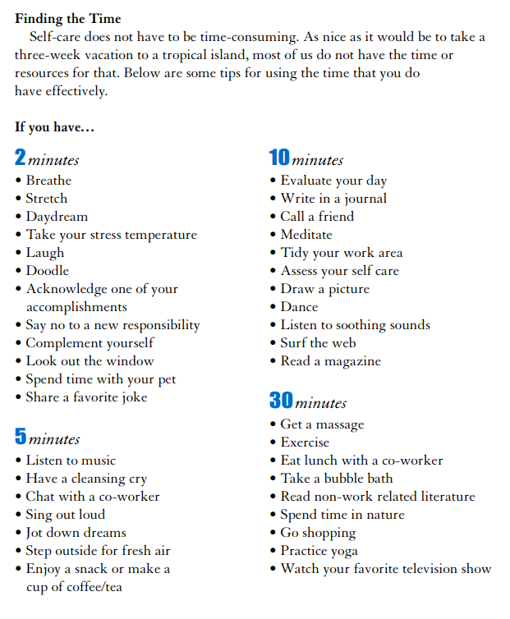
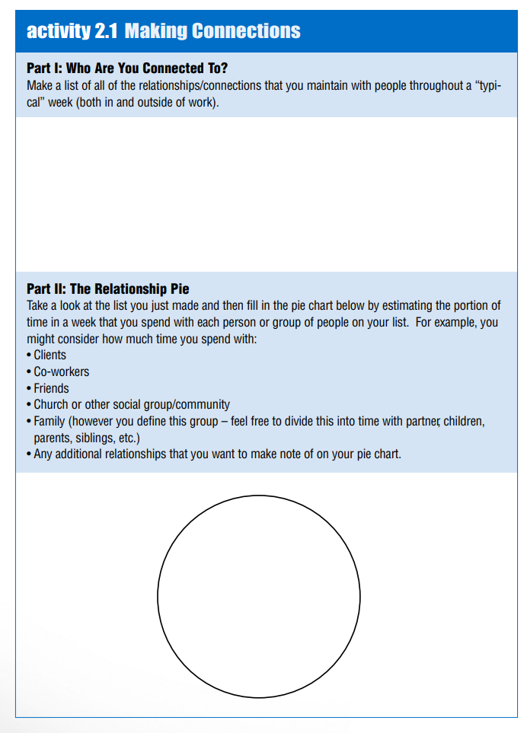
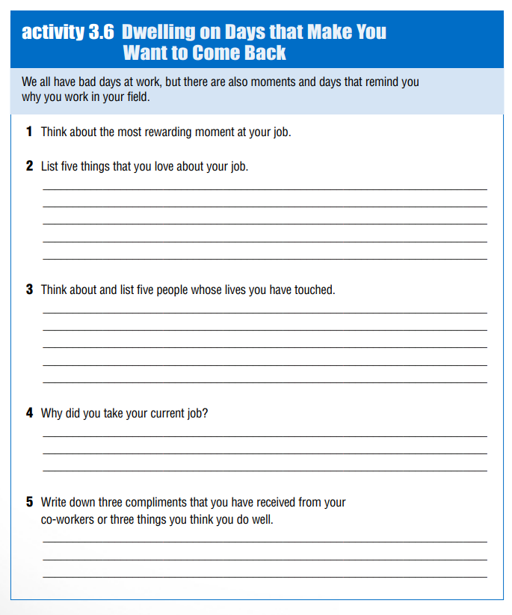

PURPOSE
____________________________________________________________________________________________________________________________________________________________________________________________________________________________________________________________
Mission
____________________________________________________________________________________________________________________________________________________________________________________________________________________________________________________________________________________________________________________________________

